Team Name: Spell-Shaded

Griffin Cecil gdcecil@wpi.edu

Craig Bursey crbursey@wpi.edu

Jonella Esposito jlesposito@wpi.edu

Jimmy Tran jntran@wpi.edu

Title: WPIn love

Tagline:

Perspective makes a world of a difference, especially when it comes to losing your

whole world.

Back-Of-Box Description:

You’ve just moved into a new institute eager to start a new life. It’s your first year

and things are going great at WPI. Slowly being less shy, you befriend a new girl in class

when she becomes your lab partner. Things start to hit off and you can’t imagine anyway to

make this a better first year, that is, until she starts to act in an unusual way. Fear,

intimidation, rejection, all because of the things she said you have said and done. You

try to figure it out, before your best friend disappears from your life. Is there something

you did that you can’t remember? Choose your actions wisely, and perhaps you can

keep her from running away. Can you keep her?

Game Features

* The ability to name your characters!
* Choose your actions!
* Unlock numerous endings depending on your choices!
* Beautiful scenes and artwork!
* Say and do the right things to win the girl!

Concept Document Relation

The experience goal that we set out to build our game around is the struggle and conflict that faces people when they first find love. This affects everybody in a different way and we have strived to provide an outlet for our player’s feelings. Through our game we have simulated the difficulties facing love from the very first choice the player makes. Choosing which side of the story a player experiences first will shape their understanding of the entire game from that point onward. The final choice of the game also serves as a means for the player to become a part of the game and really feel the emotions that the character’s themselves are and actually express those feelings. The burden of this decision will immerse the player in the story and teach them about the struggles of love at the same time. One area that we had wished to improve on was the character development of each protagonist throughout the story, but due to time constraints, would have left little to no time for polishing and finalizing the game. In order for our players to properly empathize with our characters, they must be able to like them first and with the development that we have shown, we believe we are missing a part of the development we would have liked. This hinders the experience a bit, but overall does not change the entire effect of our game.

Playtest Survey

|  |  |
| --- | --- |
| 1. | What is your gender? |
| 2. | How would you describe your experience playing WPIn Love? |
| 3. | How emotionally invested were you in the success of the main male character? |
| 4. | How emotionally invested were you in the success of the main female character? |
| 5. | When facing the final choice in the epilogue, what was your immediate reaction to the given choices? |
| 6. | How strongly did you feel about your choice made in the previous question? |
| 7. | How comfortable were you with the speed of the game (i.e. text speed, animations, narration, etc) 4 being not too slow or too fast. |
| 8. | Did the experience seem too short or too long? |
| 9. | Did anything seem confusing or misleading? If so, describe the confusion below |
| 10. | Any general comments or questions?: |
|  | |

Borrowed Assets

|  |  |
| --- | --- |
| punch.mp3 | <https://www.youtube.com/watch?v=RHFN4-BLcIo> |
| memento.mp3 | Composer: Myuu |
| lament.mp3 | Composer: Myuu |
| dramaticpunch.wav | Phoenix Wright SFX (ripped from game) |
| idea.wav | Phoenix Wright SFX (ripped from game) |
| menusound.wav | Phoenix Wright SFX (ripped from game) |
| objection.wav | Phoenix Wright SFX (ripped from game) |
| save.wav | Phoenix Wright SFX (ripped from game) |
| sharp.wav | Phoenix Wright SFX (ripped from game) |
| whack.wav | Phoenix Wright SFX (ripped from game) |
| boom.mp4 | https://www.youtube.com/watch?v=ZJ7LbYBOntw |
|  |  |

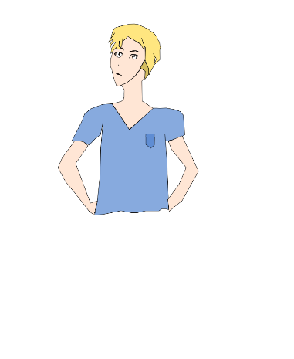 Male Original Design Game Logo 